**HW1 CSCD320**

**Question 1**

**1.**  Read the following code and answer questions.

**public** **static** **void** one(**int** a[], **int** j, **int** m)

{

**int** i, temp;

**if**(j < m) {

**for**( i = j; i <=m; i ++ ){

**if**( a[i] < a[j] ) {

temp=a[i];

a[i]=a[j];

a[j]=temp;

}

}//end of for

j++;

*one*(a, j, m);

}//end of outer if

}//end of one method

**public** **static** **void** main(String args[]) {

**int** a[] = {2, 5, 1, 7, 9, 3, 6, 8};

*one*(a, 0, a.length - 1);

System.*out*.println(Arrays.*toString*(a));

}

(a)Summarize what task(s) the method ***one*** perform? What will the **main()** method print on the screen after execution? ( 10 points)  
  
The task that method one will be performing is sorting an array in ascending order recursively. The main method will be printing the following array: {1, 2, 3, 5, 6, 7, 8, 9}.

(b) Determine the Growth Rate Function(GRF) for the method ***one***, please justify how did you get your GRF. As a separate task, then, you show the time complexity using Big-Oh notation. (40 points)  
  
Inside method *one*, ignoring the variable declarations and if statements, as they are constants at the end, it consists a for loop that will run *n* times, specifically j to m times because of the if(j < m). However each loop will increment j by 1. So it starts with n, then n-1, n-2 and so forth. Likewise, the recursive call will also run *n* times. We then get the following GRF: n + (n-1) + (n-2) + … + 2 + 1, for both the for loop and the recursive call. We can also write that as (n(n+1) / 2) or ((n^2 + n) / 2). Dropping the constants we get a time complexity of O(n^2).

**Question 2. Programming is required.**

2b)Please analyze whether the time complexity of your algorithm is (log n). **If you cannot provide a *O(log n)* algorithm, you lose a lot of points.**

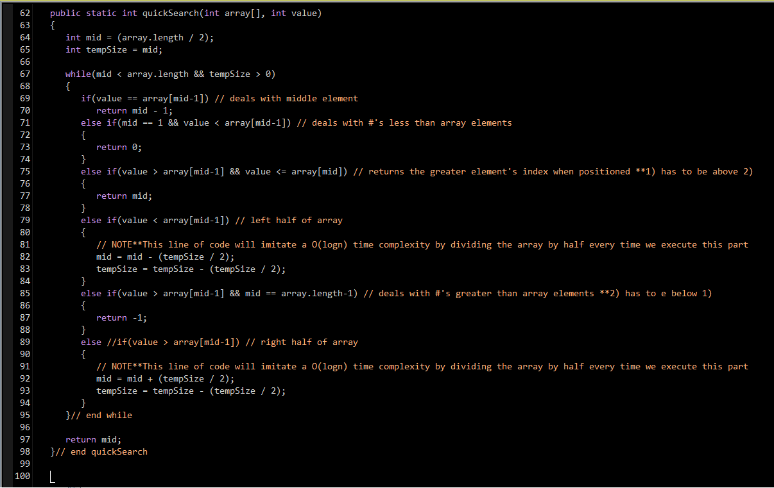

My quickSearch method has been provided above in a screenshot. The while loop consists of if, else/if, and else statements in which only one statement occurs. There are only 2 statements that continue the loop and I’ve noted them in my screenshot. The others are returning the correct index. The array begins with 8 elements. We start off placing the index right at the half way point. We use zero-indexing (0-7) so 8/2 = 3. The while loop will only loop if the index hasn’t been found. Assuming the worst case scenario, we then divide the index by half again, either moving to the left half of the array or right depending on the value passed in, which is 3/2 = 1 for left, or 5 for right. We will repeat until we reach both ends of the array.

Since we are halving our index every loop, our GRF is: 1 * 2 * 2 * 2 = 8. Simplifying we get 2^x = 8. 8 can be arbitrary, so we can replace it with *n*, so we get 2^x = n. Solving for x we get x = logn. Thus, the time complexity for my method is O(logn).